**CE4098D Major Project**

**Parametric study on prediction of compression and shear strength of silty sand using hypoplastic model**

*Submitted by*

|  |  |  |
| --- | --- | --- |
| **SL. NO.** | **NAME** | **ROLL NUMBER** |
| 1 | DASARI ASHOK | B180158CE |
| 2 | TANDRA VENKATA CHENNARAO | B180183CE |
| 3 | SURISETTY HEMA NAGA CHANDU | B170440CE |
| 4 | GOLLANGI JAGADEESH | B181068CE |

**Under the Supervision of**

**Dr. K. Ranga Swamy**

Department of Civil Engineering

*National Institute of Technology Calicut*

2021-22

**1.0 INTRODUCTION**

Silty sand is a fine-grained soil that contains silt and fine sand with uniform gradation. It exhibits low shear strength due to compressibility in loose silty sands that leads to exhibits the bearing capacity. It may be due to low frictional angles and non-plastic behaviour in nature. The strength and consolidation characteristics of silty sands depends on several parameters including void ratio, density, confinement pressure levels, friction, gradation, drainage property etc. It is necessary to understand the behavior of silty sands for the compressibility and strength properties under various loading conditions prior to construction of any infrastructure on such soil. Such silty sands are also susceptible to soil liquefaction due to high buildup of pore pressures. The mechanical behavior of granular soils, typically ranging from silt to gravel, can be modeled by different theories. Hypoplasticity stems from the framework of Rational Mechanics.Theory of hypoplasticity is a relatively recent approach to constitutive modelling of geomaterials, developed independently during the last two decades. Unlike in the theory of elastoplasticity, no distinction of elastic and plastic deformation, yield and plastic potential surfaces or hardening rules are needed.

* 1. **Need of constitutive model**:

Silty sands refer to the “relatively higher percent of sand with some percent of silt” which are normally encountered in many areas around the world. Due to the presence of fine silt material, the silty sand may highly be compressible and exhibit poor shear strength characteristics while compared with sands. It may be due to reason that almost all the soil particles are having uniform size and round in shape. Rounded particles may construct the loose silty sand deposit. Hence it is necessary to examine the consolidation and strength characteristics of silty sands by varying the affecting parameters prior to construct any infrastructure or ground improvement.

In order to determine the stress-strain behaviour of these silty sands, many constitutive models have been proposed. Modelling has become more advantageous than the experimental methods as it is faster and experimental variations and errors are avoided in these programmed simulations. Sophisticated equipment’s are required to carry out the experimental tests and it is too costlier than the numerical model. During the last two decades significant progress has been made in the development of constitutive models for predicting the mechanical behaviour of granular materials. Presently there are lots of constitutive laws to describe the deformation behaviour of soil.

The mathematical formulations are involved to make the stress-strain relations. The primary task is to develop a model to represent the exact practical applications and it should require minimum number of parameters, which can be evaluated using standard laboratory procedures. The hypoplastic law is a good choice for cohesionless soils contains the non-plastic silt particles. Also, the study of susceptibility of silty sand to liquefaction is of primary importance, as it is one of the major earthquake hazards. Foundations on saturated soils, earthen structures and slopes have been subjected to failure by soil liquefaction. So, in order to predict the susceptibility of soil to liquefaction the development of critical state model has been carried out on static liquefaction of soil.

**2.0 LITERATURE REVIEW:**

During shearing any granular soils experience specific volumetric strains. The experimental results obtained shows that some granular soils get compacted when sheared and some dilate, depending on the initial state of that corresponding soil. The initial state of any granular soil is mainly specified by the void ratio and effective stress of soil. The behaviour of sand is greatly influenced by its microstructure which implies the geometrical arrangement of individual grains and the forces acting between them. There are two most important factors which govern the strength of soils namely the magnitude of inter particle contact forces and the density of soil. Higher strength of soil can be described by the larger inter particle contact forces i.e., larger effective stress and higher densities of corresponding soil.

Traditionally geotechnical engineering involves studying, analyzing and to describe the loading and unloading response of soil in both drained and undrained conditions. Usually any granular material possesses volumetric changes on shearing, depending upon their initial state generally governed by void ratio and effective stress. The response further depends on the soil state variables which include relative density, effective stress state, fabric etc. and the intrinsic variables such as factors related to the general nature of the soil particles. Studies on clean sand have been extensively found in the past which include the behavior of loose and dense sand on shearing, their contraction and dilation, maximum and minimum void ratios, critical state friction angles, correlation of peak friction angle, dilatancy parameters etc. (Salgado et.al. 2000). In order to analyze the geotechnical problems of InSite soils which often contain significant amounts of fines, the mechanical behaviour of silty sands is to be properly studied.

**2.1 Mechanical behaviour of silty sand:**

According to IS classification system, silty and clayey sands are the soils that contain at least 50% of particles larger than 75 microns and more than 40% particles smaller than 75 μm, by weight. Further based on the plasticity characteristics of the fines among them (i.e., fraction smaller than 75 μm, that sand can be classified as Silty Sand (SM) or if the fines classify as Silt (ML) or Elastic Silt (MH). In the practice of geotechnical engineering, construction operations such types of combination of soils are generally encountered, but the information regarding their response to loading is rather limited. The comprehensive review of the experimental research and case histories from the literature regarding the mechanical behavior of soils containing plastic and non-plastic silt were presented in detail (A.H. Carraro and Salgado, 2009). Presently constitutive models play a major role in predicting the mechanical response of granular material and several models are available to analyse geotechnical problems. Among them few numerical studies were carried out to analyse the influence of various parameters affecting the mechanical behavior of silty sands

**2.2 Factors affecting stress- strain behaviour of silty sands under static loading:**

The shear strength of cohesionless soil (S) is given by Mohr – Coulomb failure criterion as follows:

S = σ tanφ ----- (2.1)

where S = Shear strength, σ = normal stress and φ = angle of internal friction and cohesion c = 0 for cohesionless soil. In general, the loose sand contracts and the dense sand dilates as it approaches the critical state on shearing, however the response depends on the initial state of the soil also. The state corresponding to no further change in shear strength and volume of specimen is called critical state and the corresponding friction angle is called critical state friction angle. For dense sands the effective stress varies directly with the loading and reaches to peak value and then again it shows inverse variation and reaches down to critical state. Whereas for loose sands the effective stress increases monotonically until it reaches the critical state and then strain increases without further change in shear stress or volume. At critical state, the soil fabric is being rearranged continuously with a friction angle equal to φc without any volume change. Volumetric straining due to shear loading before the approach of critical state causes changes in the rate of dilation which ultimately affects the shear strength also. This effect can be measured by the dilatancy angle ψ. The volumetric strain changes at different stages of shear loading can be described by the stress-dilatancy relationship. The relationship between the friction and dilatancy angles can be given as

φ = φc + ϕ (Bolton, 1986) ------ (2.2)

**2.3 Hypoplastic model:**

It represents an advanced constitutive model which has performed well in modelling the stress-strain behaviour of granular materials. “Hypo plasticity is a constitutive law of the rate type. It is a relation which associates the strain rate to the stress rate.” This model was developed from the rational mechanics and it provides a single constitutive equation describing many important features of the behaviour of granular soils. The original hypoplastic equation was introduced by Kolymbas in 1977 and later on improved versions were developed by several researchers (Kolymbas 1991, Wu &Bauer 1994, Bauer 1994, Herle 1999, Herle and Gudehus 1999).

This constitutive equation of the hypoplastic model is very simple, represented by a stress-strain relationship embedded in a single tensorial equation without explicitly defined yield and potential plastic potential surfaces. It considers the influence of mean pressure and density on the overall behaviour of granular soils. In order to improve the small strain behaviour of the model after abrupt changes in the direction of stress or strain paths and to avoid excessive ratcheting in the range of small load cycles, (Niemunis and Herle, 1997) have modifies the original model by adding the new state parameter called intergranular strain. This model was applied for a wide range of geotechnical problems by various researches in Germany for earth pressure problems, estimation of foundation settlements and bearing capacity of soils, modeling the cone penetration test, static and dynamic response of soils. In the past years many constitutive models based on the theory of hypoplasticity have been developed for granular materials. This model describes the behavior of soil very realistic, i.e. non-linear and inelastic. The software code was formulated by Kolymbas (1991) and was coded by Herle (1996) in FORTRAN 77 after implementing the mathematical formulations of hypoplastic model and it is called HYPO element test program.

This program needs three input data files include material parameters, initial conditions and test parameters to run the analysis. The required eight numbers of material parameters for the model are to be determined by carrying out the basic laboratory tests. These parameters in turn are closely related to the granulometric properties include critical friction angle (φc), granulate hardness (hs) exponent (n), minimum void ratio (ed0) at zero pressure, maximum void ratio (ei0) at zero pressure, critical void ratio (ec0) at zero pressure, exponent (α), and exponent (β). These are called state parameters those are constant for the particular type of granular soil.

**3.0 OBJECTIVES AND SCOPE**

Major objective of the present study is to study the consolidation and shear strength characterization of silty sand using hypoplastic model under various test and soil conditions. It also includes,

* To validation the hypoplastic model with published experimental data under drained triaxial loading
* To obtain material input parameters for silty sand and use them as input into the HYPO element test numerical programme.
* To perform the numerical simulations on drained triaxial testing and presenting the test results with (i) stress strain variations, (ii) volume change with strain during shearing stage, and (iii) stress paths for a particular density i.e. void ratio and consolidation pressures.
* To study the effect of initial conditions including variation of material parameters on the drained response of fine silty sand.
* To study the mechanical behaviour of silty sand that behaves as contraction or dilation that concerning with initial state of soil in terms of (i) stress ratios, and (ii) volume changes at failure state of 20% axial strain, and (iii) critical-state line concept.
* To perform the numerical simulations on oedometric compression and study the influence of various parameters on compressibility of silty sand

**4.0 METHODOLOGY**

It involves the sequential steps of activities to complete the objectives of the current project. It includes

* Collection of literature papers
* Avail the input material parameters into Hypo element programme
* Validation of numerical model with real experimental data
* Perform the numerical simulations on silty sand with drained triaxial and oedometric compression loading
* Analyse and study the effect of various parameters on mechanical behaviour of silty sand
* Report preparation

**5.0 WORKS DONE SO FAR**

Hypoplastic parameters used for the silty sand contain silty fines of 30% are obtained from the PhD thesis of Ranga Swamy K (2009) and are listed in Table 5.1. These parameters were determined from the basic experimental tests and using mathematical formulations of hypoplastic model.

Table 4.1 Hypoplastic parameters of sand-silt mixture with 30% silty fines

|  |  |  |  |  |  |  |  |  |
| --- | --- | --- | --- | --- | --- | --- | --- | --- |
| Silty sand with | *ϕcv*  (°) | *hs*  (MPa) | *n* | *edo* | *eco* | *eio* | *α* | *β* |
| 30% fines | 34.5 | 90 | 0.405 | 0.620 | 1.015 | 1.167 | 0.136 | 0.398 |

Initially, the Hypo model simulations are validated with experimental data provided by Ranga Swamy K, (2009). Variation of compression with applied pressure under oedometer compression testing is shown in Fig. 1 for the comparison. It shows that the response is well coincide and the model is validated. Further numerical simulations are made on CD triaxial testing response of silty sand to obtain the (i) stress strain variations, (ii) volume change developed during shearing stage, and (iii) stress paths for a particular density i.e., void ratio and consolidation pressures. It also studying the effect of initial conditions on stress ratio, critical void ratio and stress paths.

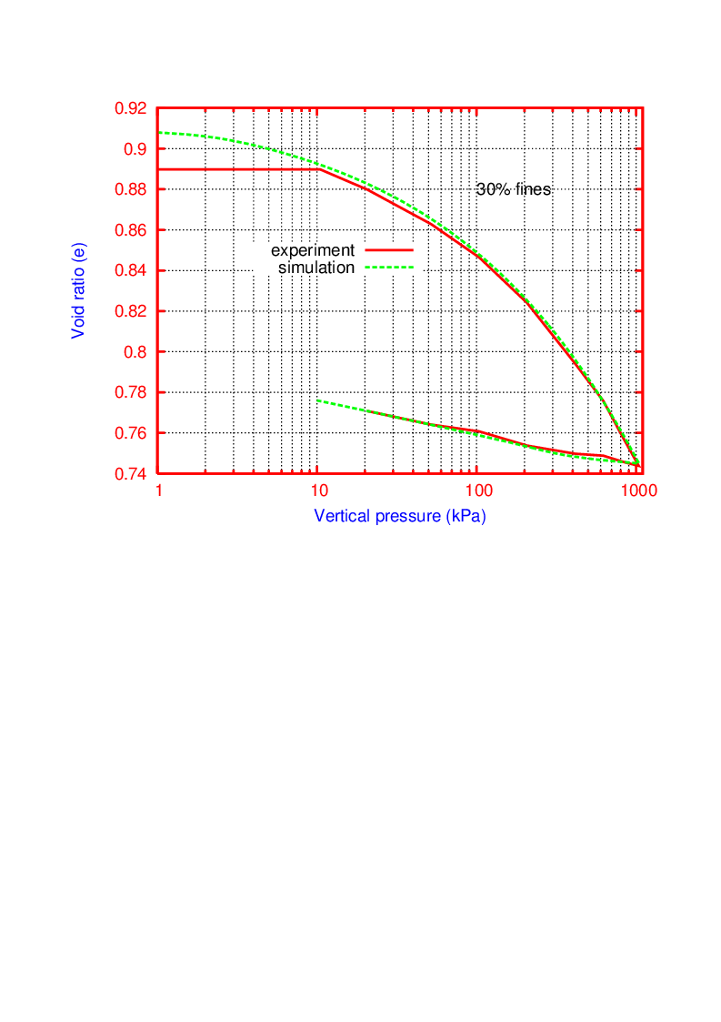

Fig. 1 Comparison of model simulation with experimental data

5.1 Drained response of silty sand at Void ratio of 0.99

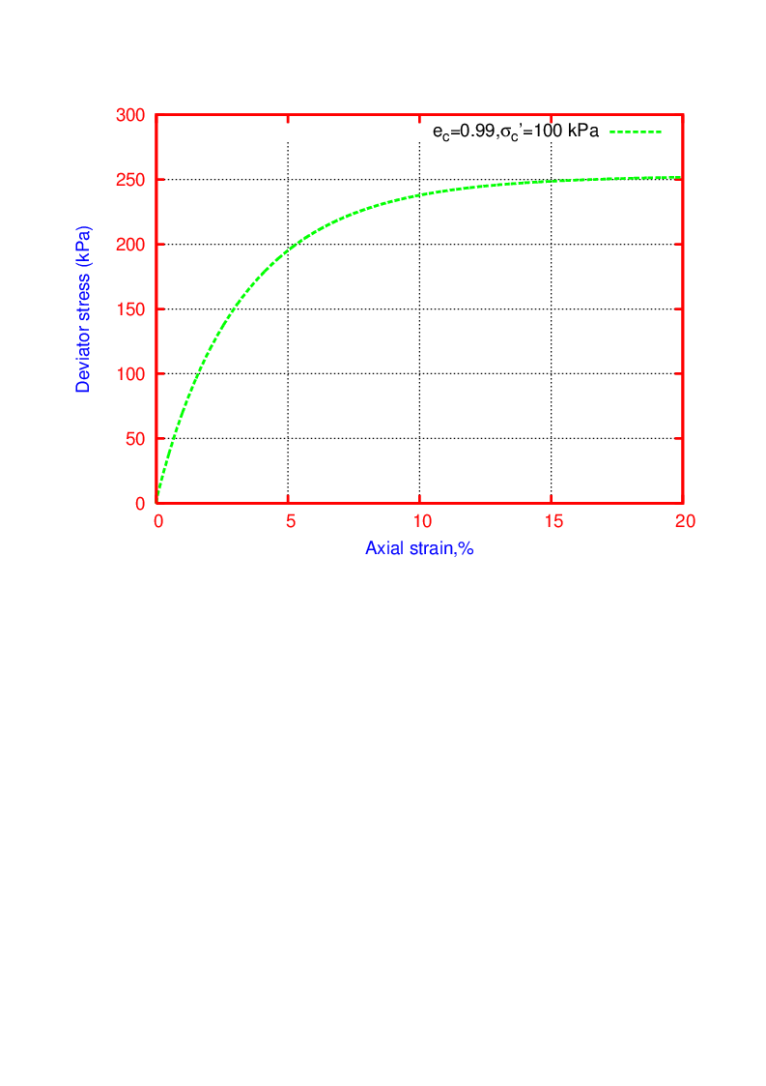

Fig. 2: Deviator stress versus axial strain (ec = 0.99 and σc=100 kPa)

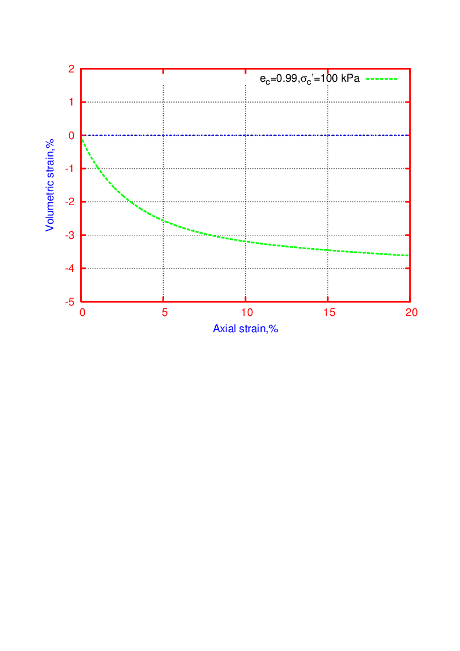

Fig. 3: Volume change versus axial strain (ec = 0.99 and σc= 100 kPa)

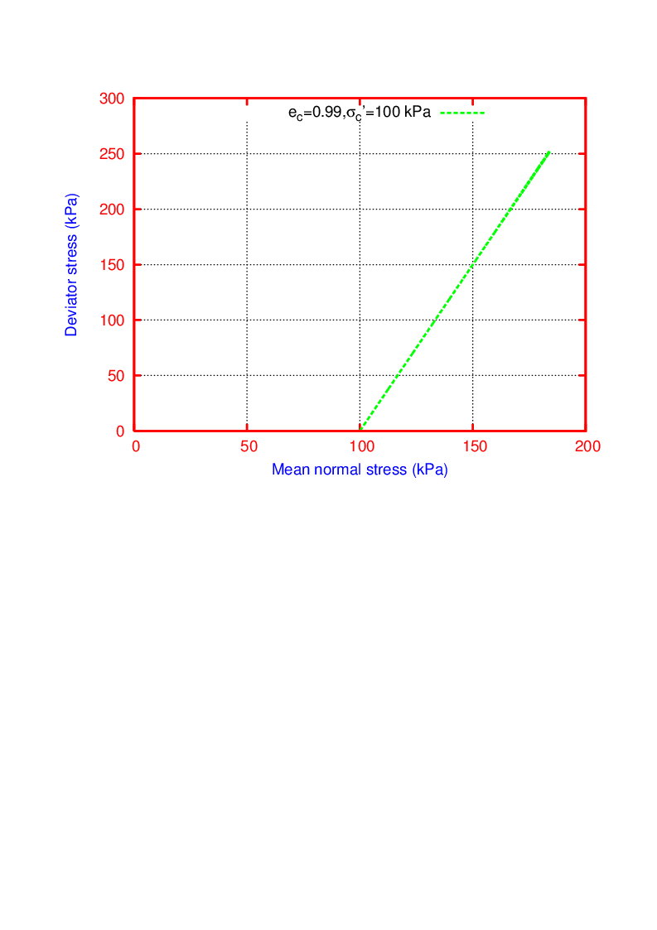

Fig. 4: Stress path (ec = 0.99 and σc= 100 kPa)

5.2 Drained response of Silty sand at Void ratio of 0.85

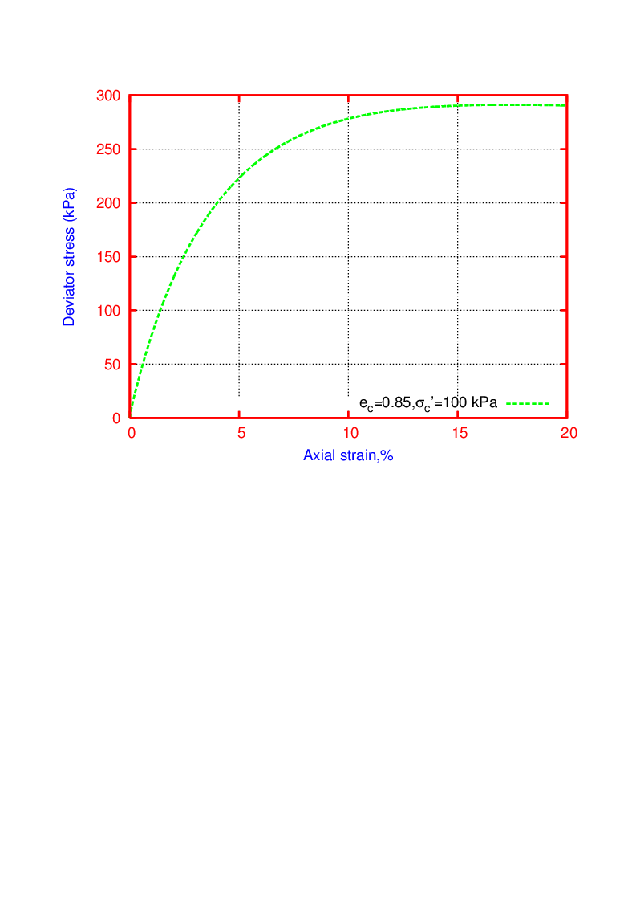

Fig. 5: Deviator stress versus axial strain (ec = 0.85 and σc=100 kPa)

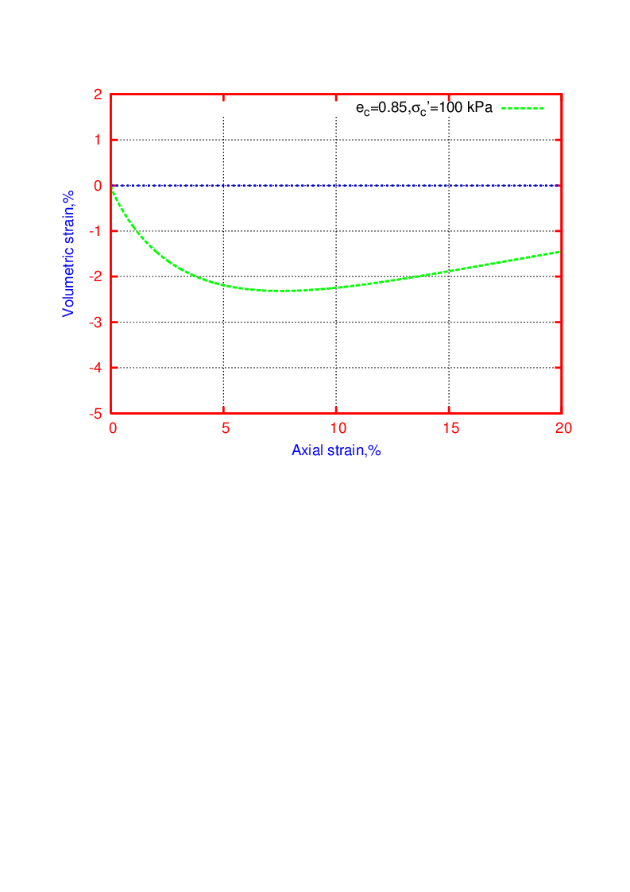

Fig. 6: Volume change versus axial strain (ec = 0.85 and σc= 100 kPa)

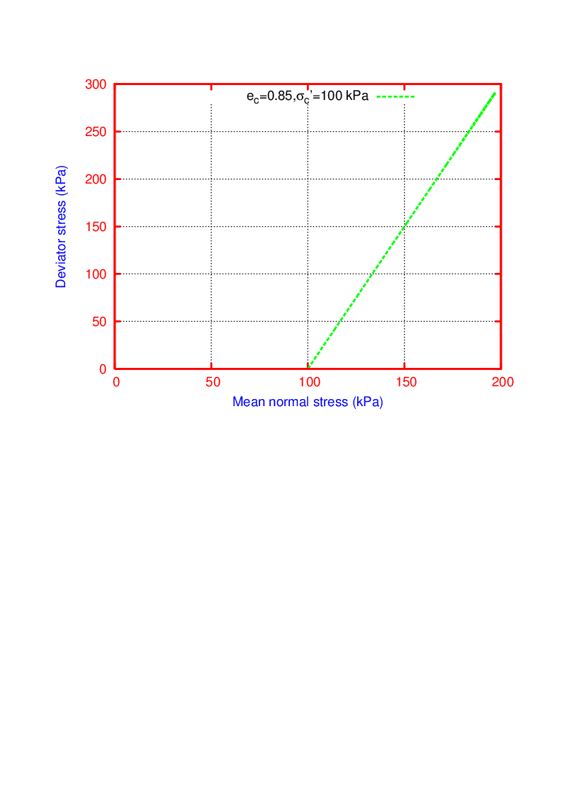

Fig. 7: Stress path (ec = 0.85 and σc= 100 kPa)

**5.3 Effect of void ratio (Relative density) on drained response of Silty sand**

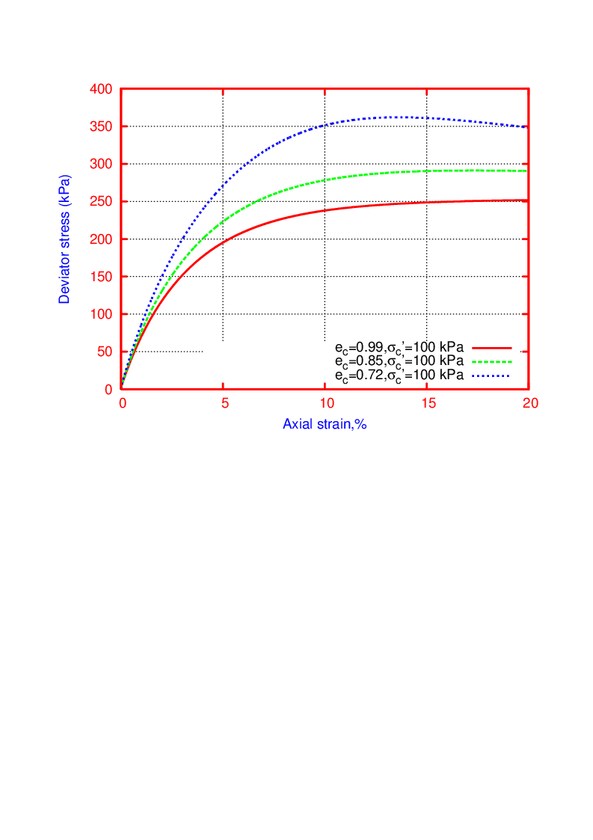

Fig. 8: Variation of deviator stresses with void ratios

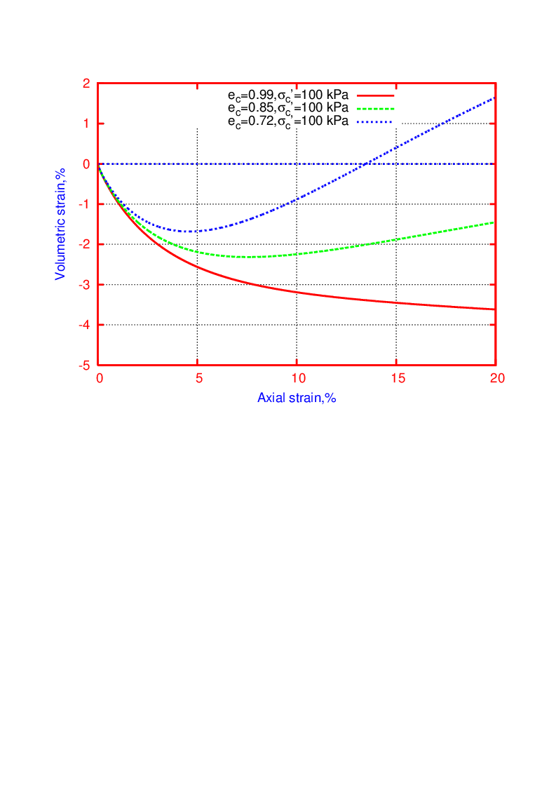

Fig. 9: Variation of volume change with void ratios

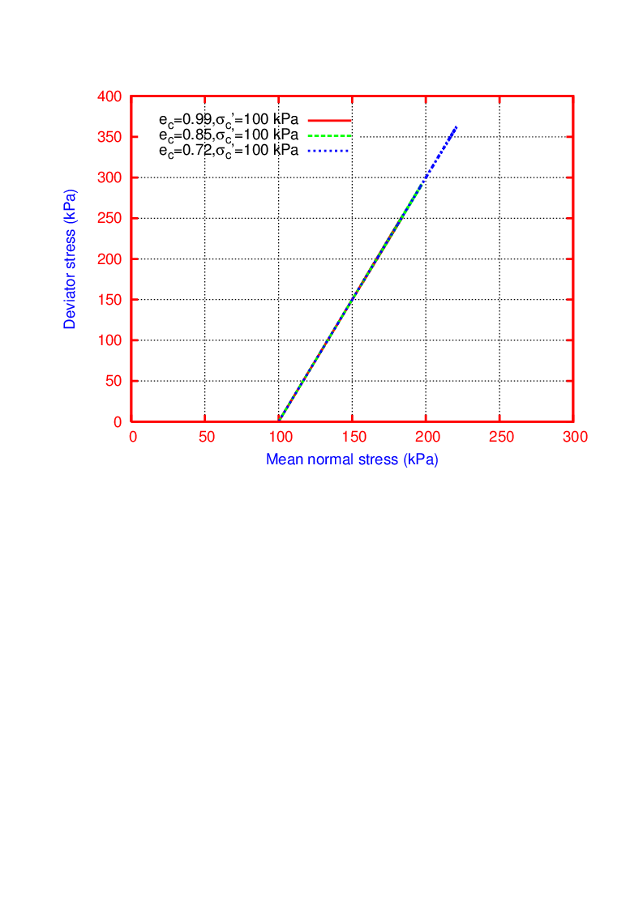

Fig. 10: Variation of stress path with void ratios

**5.4 Drained response of Silty sand at consolidation pressure of 50 kPa**

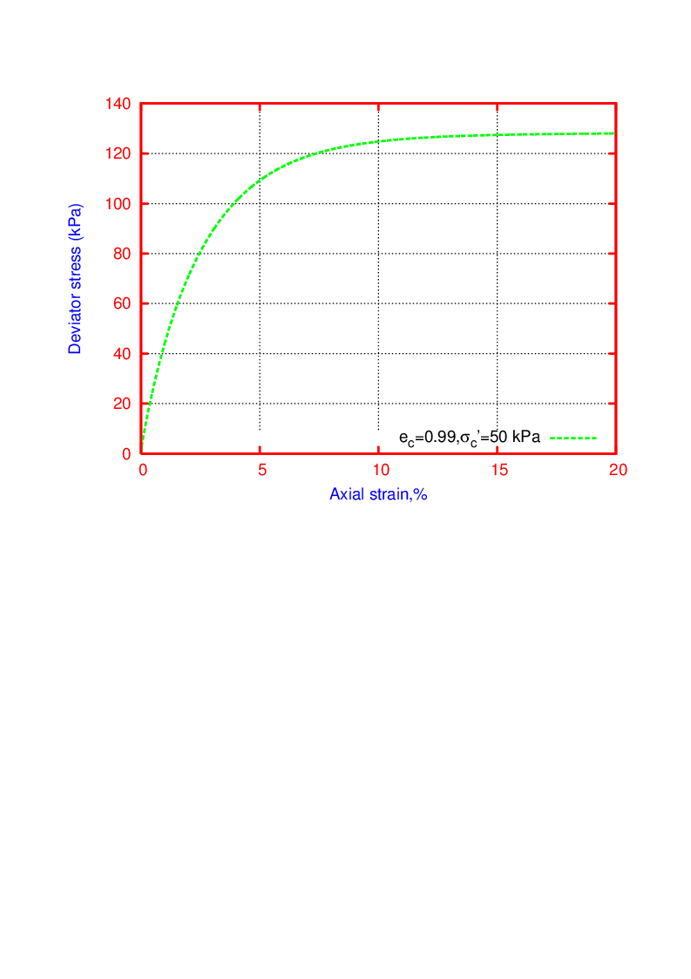

Fig. 11: Deviator stress versus axial strain (ec = 0.99 and σc=50 kPa)

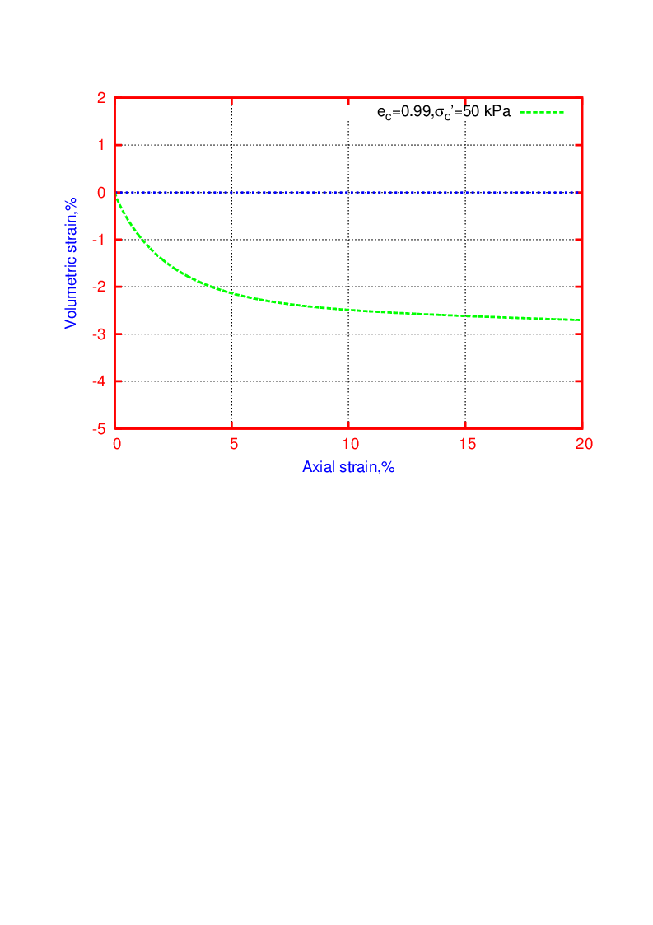

Fig. 12: Volume change versus axial strain (ec = 0.99 and σc= 50 kPa)

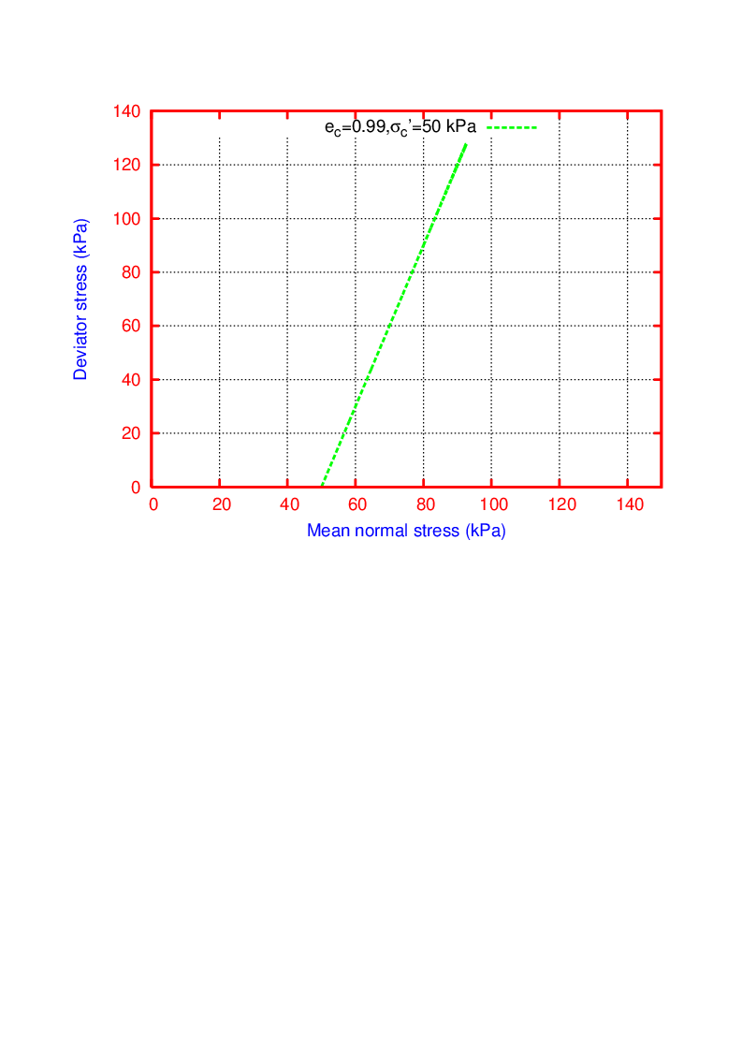

Fig. 13: Stress path (ec = 0.99 and σc= 50 kPa)

**5.5 Effect of consolidation pressure on drained response of Silty sand**

*5.5.1 Very loose silty sand (e=0.99 and Rd=15%)*

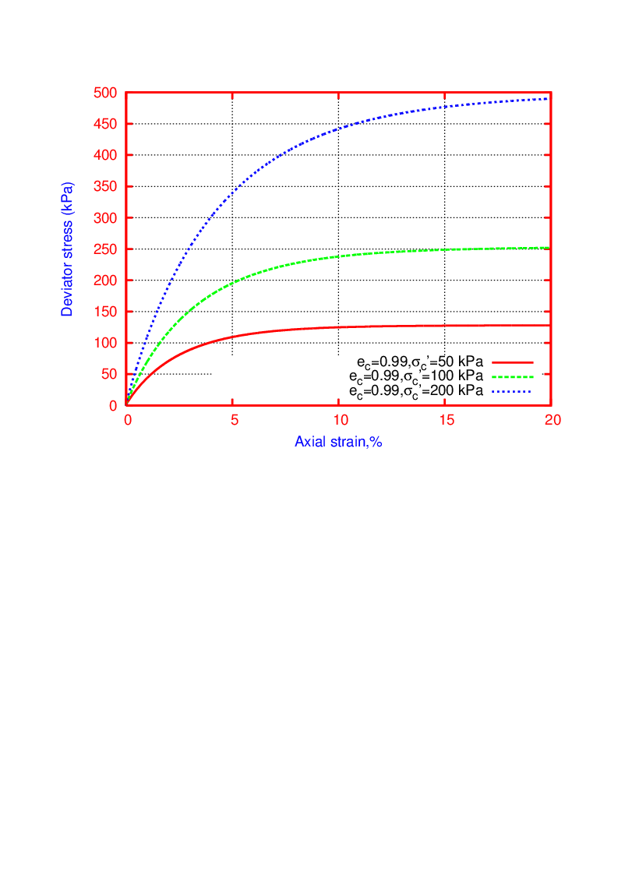

Fig. 14: Variation of deviator stresses with consolidation pressures

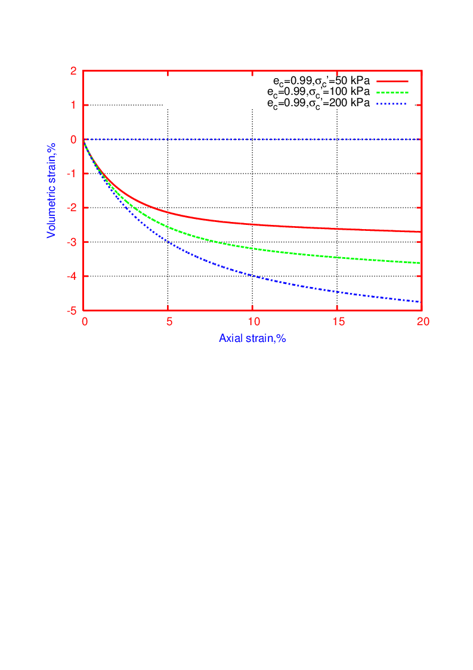

Fig. 15: Variation of volume change with consolidation pressures

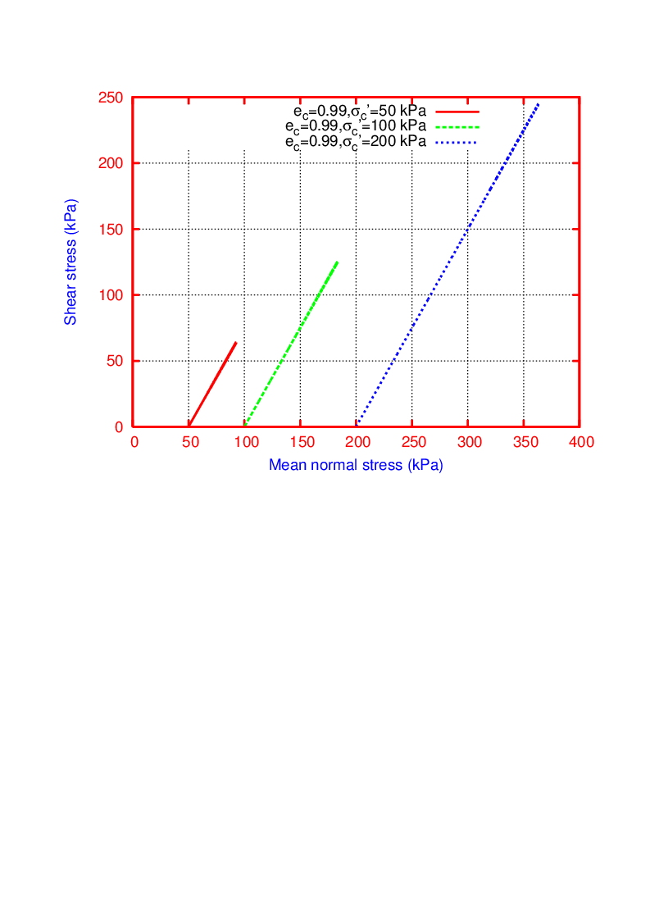

Fig. 16: Variation of stress path with consolidation pressures



Fig. 17: Failure envelope to evaluate the shear strength of loose silty sand (ec=0.99)

*5.5.2 loose silty sand (e=0.85 and Rd=40%)*

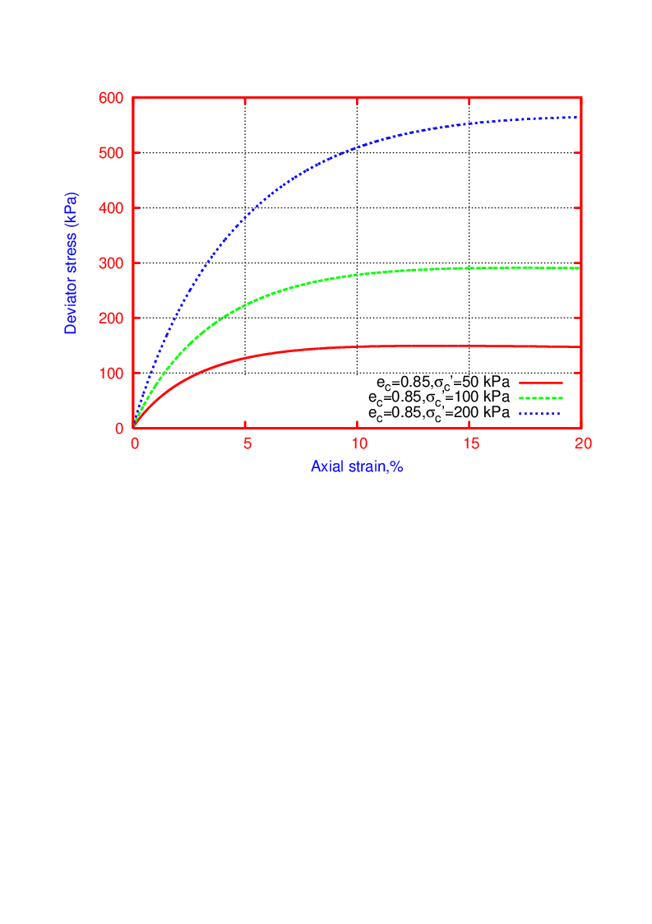

Fig. 18: Variation of deviator stresses with consolidation pressures

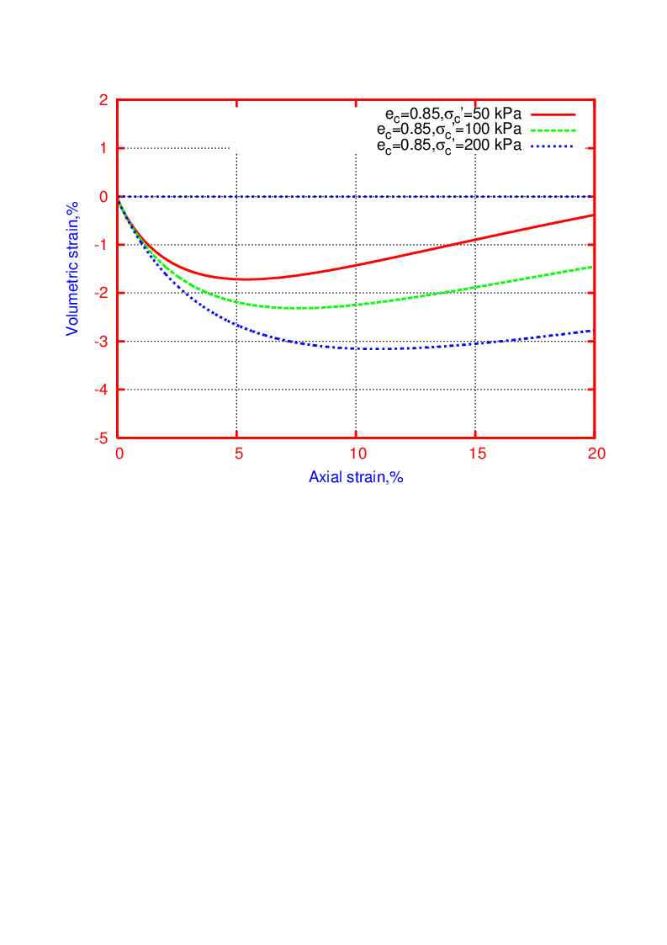

Fig. 19: Variation of volume change with consolidation pressures

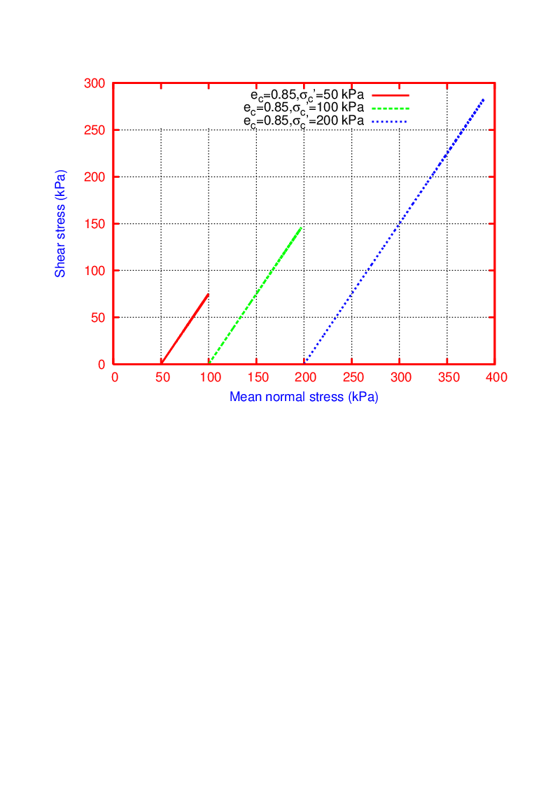

Fig. 20: Variation of stress path with consolidation pressures



Fig. 21: Failure envelope to evaluate the shear strength of loose silty sand (ec=0.85)

*5.5.3 Dense silty sand (e=0.72 and Rd=70%)*

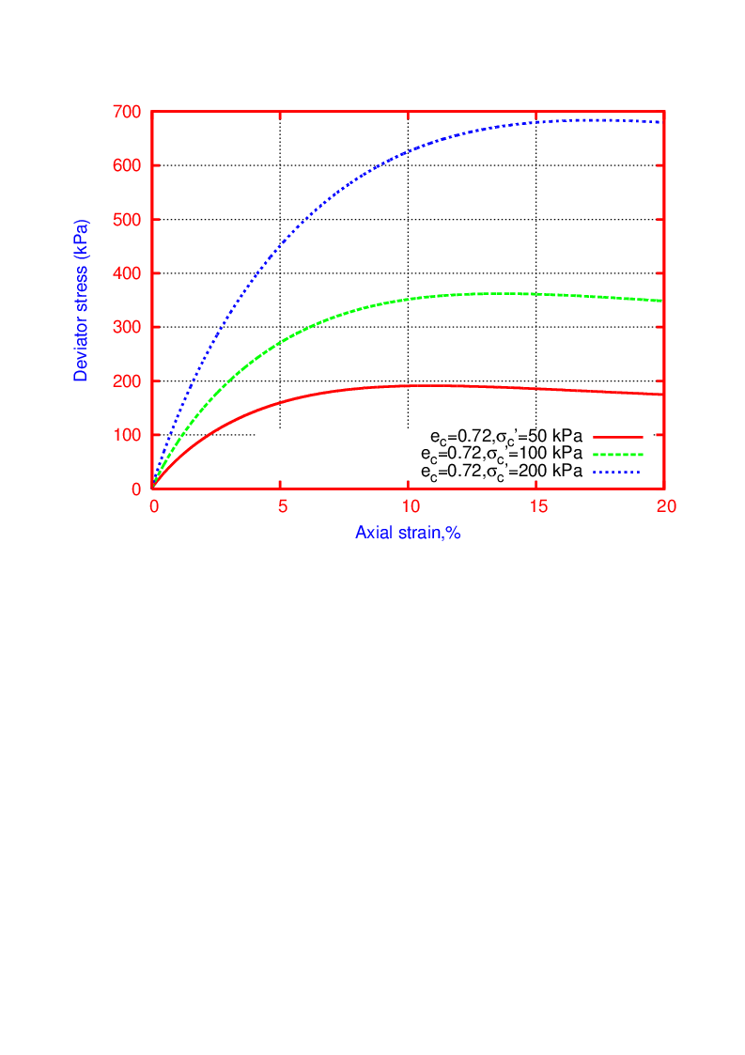

Fig. 22: Variation of deviator stresses with consolidation pressures

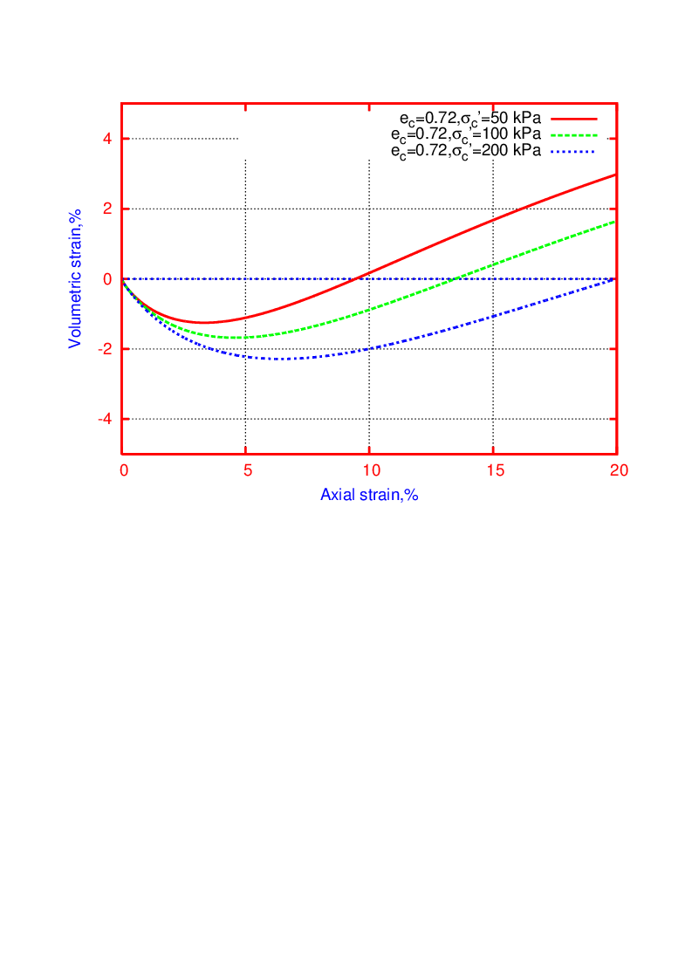

Fig. 23: Variation of volume change with consolidation pressures

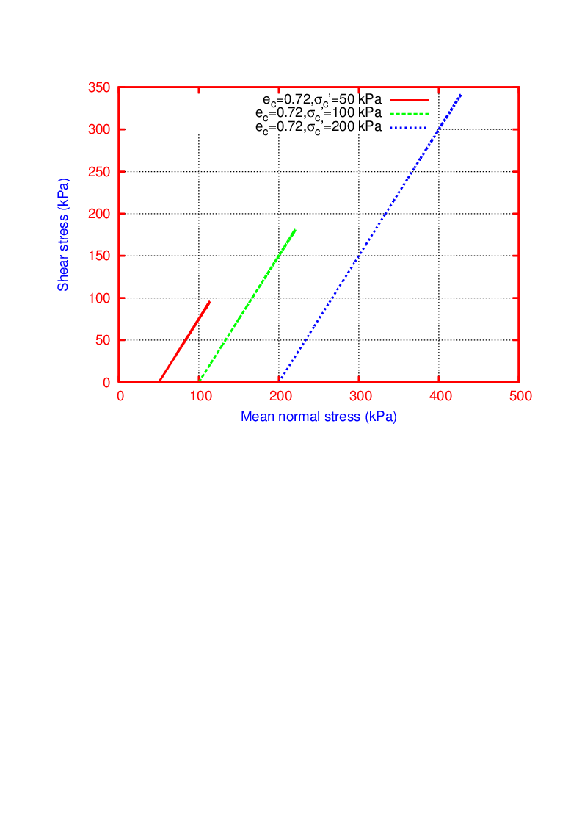

Fig. 24: Variation of stress path with consolidation pressures



Fig. 25: Failure envelope to evaluate the shear strength of loose silty sand (ec=0.72)

**5.6 Effect of relative density (void ratio) on shear strength of silty sand**



Fig. 26: Effect of relative density (void ratio) on shear strength of silty sand

**5.7 Evaluation of liquefaction susceptibility of silty sand**

To evaluate the liquefaction susceptibility of silty sand in terms of stress ratios, and volumetric strains at failure strain of 20% axial strain levels, the stress ratios and volumetric strains are recorded from the drained responses of silty sand shown in Figs. 14 to 24. Table 2 summaries the variation of stress ratios and volumetric strain at 20% axial strain and the figures 27 to 29 are presents the liquefaction susceptibility of silty sand with concerning consolidation pressures and void ratios. Critical void ratios are computed in the loosest possible silty sand at 20% axial failure strain.

**Table 5.2 Variation of stress ratios and volumetric strain at 20% failure strain**

|  |  |  |  |  |
| --- | --- | --- | --- | --- |
| **Initial void ratio, eo** | **Cons. pressure, kPa** | **Deviator stress ratio (σd/σ3)** | **Volumetric strain, %** | **Critical void ratio** |
| 0.99 | 50  100  200 | 2.56  2.49  2.45 | -2.7 (compression)  -3.5  -4.8 | 0.936  0.921  0.894 |
| 0.85 | 50  100  200 | 3  2.7  2.65 | -0.4  -1.5  -2.8 | --  --  -- |
| 0.72 | 50  100  200 | 3.6  3.5  3.35 | +3 (Extension)  +1.8  +0.2 | --  --  -- |



Fig. 27 Evaluation of liquefaction susceptibility in terms of stress ratio



Fig. 28 Evaluation of liquefaction susceptibility in terms of volumetric strain



Fig. 29 Evaluation of liquefaction susceptibility based on critical state line

Further the numerical simulations are to be made to evaluate compressibility characteristics of silty sand by varying the material strength parameters of Hypo model.

**Conclusions:**

* Dense silty sand with low void ratios are exhibiting low compression volume change or increase of dilation. It leads to increase of the deviator and mean normal stresses with increase the density of silty sand.
* Even at loose state of silty sand, deviator and mean normal stresses are increasing with increase of consolidation pressures. It also seen that the compressibility of volume change increases with increase of consolidation pressures.
* Shear strength of silty sand increasing with increase of relative densities (void ratios) from 25 to 70% (e =0.99 to 0.72).
* Silty sand at low consolidation pressures exhibit high stress ratios that indicates less or not susceptible to liquefaction than at higher pressures. At particular pressure application, dense silty sand possesses high stress ratios indicating less or not susceptible to liquefaction than the loose silty sands.
* Silty sand at low consolidation pressures exhibit low compression or high extension deformations that indicates less or not susceptible to liquefaction than at higher pressures. At particular pressure application, dense silty sand possesses dilatational deformation indicating less or not susceptible to liquefaction, however the loose silty sands exhibit compression deformations indicating more liquefiable.
* Critical state line shows that the liquefaction susceptibility of silty sand is dependent on both the combination of consolidation pressures and void ratios i.e. initial state. For example, even the dense silty sand could liquefy at higher consolidation pressures.

**References**

1. Antonio H. Carraro *et al*. (2009), “Shear strength and stiffness of sands containing plastic or non-plastic fines.” *J. Geotech. Geoenviron. Eng*., 135 1167-1178.
2. E. Bauer and W. Wu *(1994*). “A hypoplastic model for granular soils under cyclic loading”. In D. Kolymbas, editor, Modern Approaches to Plasticity, pages 247–258. Elsevier Science Publishers B.V., 1993.
3. Herle and G. Gudehus (1999), *“*Determination of parameters of a hypoplastic constitutive model from properties of grain assemblies”, *MECHANICS OF COHESIVE-FRICTIONAL MATERIALS, Mech. Cohes Frict. Mater. 4, 461-486,* 1999.
4. Kolymbas D (1991), *“*Introduction to Hypoplasticity*”. Advances in Geotechnical Engineering,* Volume 1. A.A. Balkema publications
5. Rangaswamy K (2009), “Undrained response and liquefaction susceptibility of sand silt mixtures under Cyclic triaxial loading”, PhD Thesis, IIT Madras.
6. Salgado, R. *et al.,* (2000), “Shear strength and stiffness of silty sand.”, *Journal of Geotechnical and Geoenvironmental Engineering*, 126(5), 451-462.

**Verified and approved by:**

(Name and dated signature of Supervisor)